The Meander and the Labyrinth

There are several links between labyrinths and water. The word labyrinth comes to us from Caunia in South-Western Turkey. It was a Greek colony, but the words "labyrinth," and "labrys," the double-headed axe much admired by feminists today, both come from a culture that was there before the Greeks arrived. And this was a matrifocal culture. A time, as Merlin Stone put it in the title of her seminal book, "When God was a Woman." It is in Caunia that we also find the Meander River. There is a form of art from the Eastern Mediterranean called the meander. It is also known as the Greek Key:

Meander Meander or Greek Key Meander

Labyrinth Key
As I have shown in my book, " Labyrinths: Ancient Myths & Modern Uses,"
if you imagine a hinge on one endof the meander, it fans out into a labyrinth.

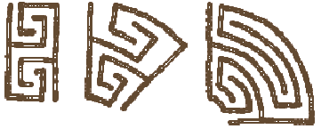

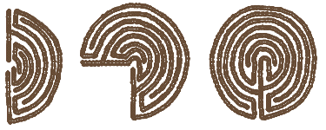

The Classical Seven Circuit (left-handed) Labyrinth

Anthropologist, Archaeologist and wise Crone Marija Gimbutas found that this meander pattern goes back to the Bird Goddess of Old Europe, an area that she defined as covering the Balkans down through Albania and Southern Italy and Sicily. Dr Gimbutas traced the Bird Goddess and this meander pattern through the stratigraphy of Old Europe back to at lEast 15,000 BCE! Would it be an understatement to say that that's a long long time ago? That's back when Cro Magnon was painting pictures on cave walls! When God was a woman.

Fourteen-thousand years later, the Greeks colonized the Meander River shortly before the time of Christ. They gave us the meander pattern, which they renamed the Greek Key. They also told us that "to meander" meant "to wander aimlessly." That is not what's going on in a labyrinth. To the left brain, it may look like that, but in addition to being beautiful to the eye, like her sister-in- divination, dowsing, these single-path magical mazes are also excellent tools of divination.

It looks like the Greeks didn't have the key after all. They didn't have a clue. Ariadne convinced Daedalus, designer of the Cretan maze to give her the clew - the ball of yarn. She did have the key. The Meander River

The Meander River is special. All other meandering rivers are named after this one. In the geological cycle of a river, meandering happens at the end. It is something a river does after it has ground out the mountain into a valley, and then carved the valley wide enough so that it can finally snake back and forth on its way to the sea. Meanderings are done by the old ones in Water's cycle. The Element Water is feminine. Perhaps labyrinths are a tool of the Crone, or wise old woman?

Meanders and Water Meandering is actually a very efficient way of traveling when there is not much drop in elevation. Moving from side to side. Theodore Schwenk writes in "Sensitive Chaos" about the work of hydrological genius Victor Schauberger. Schauberger studied flowing water in all of its forms including the meander. Schwenk writes, "A meandering motion lengthens the course of a river and thus slows down the speed at which it flows. In this way the river bed is not hollowed out, the ground water reserves are left intact." (Schwenk. p 18.)

Used as a metaphor for walking a labyrinth, the path slows down the speed at which you walk or flow over a longer distance In this way, your passing is not so abrasive to the path, and you do not draw from the reserves outside yourself. They come from within.

Water and humans meet in sacred space. She is always underneath. Below. Her juvenile waters surface as Holy Wells. Water is our Mother's blessing. (I just can't live without it!) Old, wandering, flowing water carries labyrinth energy. What Wisdom can She bring us?
(http://www.geomancy.org/e-zine/1997/summer/dowsing-labyrinths/index.html)

