Leader: Mother Teresa (1910-1997)
Category: Humanitarian

Background Information
This section introduces the leader as well as the leadership process/role they were involved in. It also considers what were their motivations or goals.
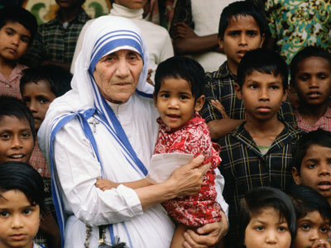

Mother Teresa founded the Missionaries of Charity after receiving Vatican permission on October 7, 1950. Its mission was to care for “the hungry, the naked, the homeless, the crippled, the blind, the lepers, all those people who feel unwanted, unloved, uncared for throughout society, people that have become a burden to the society and are shunned by everyone.” Through the work of the Missionaries of Charity she opened hospices for the dying, homes for those suffering from leprosy, orphanages, hospices for AIDS sufferers, and charity centers for the blind, the homeless, alcoholics, refugees, the disabled and for those people affected by famine, epidemics and natural disasters. The Missionaries of Charity began as a small order with 13 members. At the time of her death in 1997 there were more than 600 missions operating in over 123 countries. In 1979 Mother Teresa was the recipient of the Nobel Peace Prize.

Relationship to Course Material
This area discusses the leader’s profile and how it relates to definitions, descriptions, models, and approaches considered in class. Specifically we will be considering how their leadership experience shows evidence of transformational leadership.
Her goals are clearly stated in her mission statement and her actions certainly supported her goals. She inspired leaders throughout the world to support her causes. She was able to transcend religious beliefs and political ideologies. Mother Teresa travelled to war zones, areas hit by natural disasters and countries ravaged by epidemics and famine in order to minister to those in need.

http://www.nobelprize.org/nobel_prizes/peace/laureates/1979/teresa-lecture.html

When looking at the 16 basic desires of the Reiss Motivation Profile®, I would have to say that Mother Teresa’s strongest motivators would be: power, idealism, social contact, honour and family.

“We ourselves feel that what we are doing is just a drop in the ocean. But the ocean would be less because of that missing drop.” (Mother Teresa)

As stated by Northouse “transformational leadership is the process whereby a person engages with others and creates a connection that raises the level of motivation and morality in both the leader and the follower.” (p.186)

Northouse went on to state “transformational leadership results in people feeling better about themselves and their contributions to the greater common good”. (p.200)

Supporting Evidence
This section outlines why this example supports our overall perspective on leadership and key arguments and ideas. Specifically we will be considering how this example relates to leader/follower engagement and context.
Mother Teresa has, through her actions and words, clearly demonstrated the qualities that define transformational leadership. While it is true that she felt a need to commit herself to a religious life, it is also clear that she surpassed her duties with her choice to embrace and minister to the unwanted members of society throughout the world.

“One of the greatest diseases is to be nobody to anybody.” (Mother Teresa)

The Missionaries of Charity continues to grow and is currently active in over 133 countries throughout the world with more than 4,500 sisters carrying on Mother Teresa’s work. She saw a need and acted upon it. She had no money and had to beg for food and supplies in order to be able to help those in need. Mother Teresa gained the attention of Indian government officials. Within a few years she had begun attracting recruits and donations. As she recognized yet another need the Missionaries of Charity expanded to accommodate them as well.

Mother Teresa’s tireless work on behalf of the “unwanted” and the resulting legacy still thriving today would have to be, in my opinion, a textbook definition of leader/follower engagement.

