Name: Jordan Potynski
Levels of Organization Pyramid Period: 5

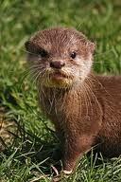
Organism; an individual living creature
This is an example because it is an individual living thing.

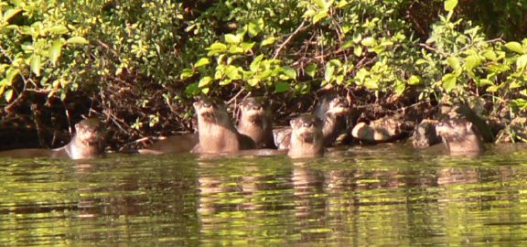
Population; group of the
Organisms living in the same area
This is an example because it is a bigger amount of one animal in one location

Community; a group of
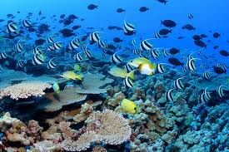
Different organisms sharing
This is an example because it is a group of different organisms that would live in the same environment.
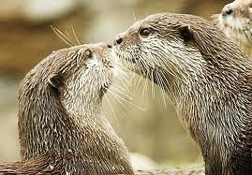
The same environment.
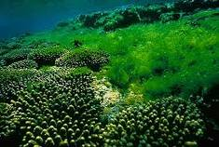

This is an example of an ecosystem because in a lake living and non-living thing interact like an otter, fish and algae.
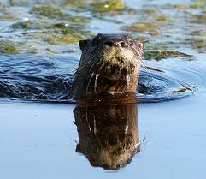
Ecosystem; place where
Living and non-living things
interact

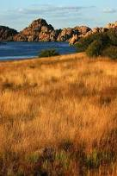
This is an example because with the grassland and lake combined they are two different ecosystems determined by their climate and elevation.
Biome; many
Ecosystems;
Determined by
Climate and
Elevation.
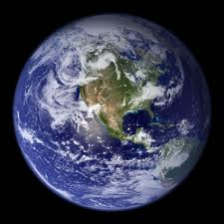
This is a biosphere because it is one giant ecosystem and it all works together.
Biosphere;
Earth as
One ecosystem

