Magnetic Forces

Read the information below
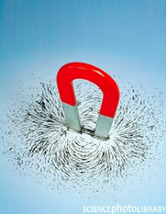
History of Magnetism
The Chinese discovered the magnetic compass as early as 200 BC. At first fortune-tellers used it. Later people realised that it was a way to find the direction of North and South.
The ancient Greeks knew that the lodestone or magnetite attracted iron towards it. It is known that the Vikings used a lodestone to navigate. Later at the end of the twelfth century Europeans were using this simple compass to aid navigation.
During the 16th century Sir William Gilbert discovered that the properties of the lodestone could be transferred to ordinary pieces of iron by rubbing them with a lodestone.

What is a Magnet?
The first magnets were made of iron. These days they are:

- alloy magnets that contain metals such as
iron
nickel
copper
cobalt
aluminium
- ceramic magnets that are made from powders called ferrites which contain iron oxide and barium oxide.
Permanent magnets do not readily lose their magnetism.

What Do Magnets Do?

- They attract certain materials eg
iron
steel
nickel
cobalt
- Magnetic materials are attracted to the poles of the magnet.
On a bar magnet the poles are at either end of the magnet. Poles occur in pairs of equal strength.
- One pole - North seeking pole - N pole- pointing roughly to the Earth's North pole.
Other pole - South - S pole
- Like poles repel
Unlike poles attract
- Force between magnetic poles decreases as their separation increases.

Test for a Magnet
A permanent magnet causes repulsion with one pole when the poles are brought in turn near a suspended magnet.
An unmagnetised magnet material would be attracted to both poles.
Repulsion is the only sure test for a magnet
- Magnetism can work over a distance and magnets can exert a force (push or pull) on objects without making contact with them.
Just think about the effect of the Earth's magnetic field on a compass needle.

Theory of Magnetism

If a magnetic piece of steel rod is cut into smaller pieces, each piece is a magnet with a N or a S pole.
Therefore a magnet can be said to be made of lots of "tiny" magnets all lined up with their N poles pointing in the same direction. At the ends, the "free" poles of the "tiny" magnets repel each other and fan out so the poles of the magnet are round the ends.
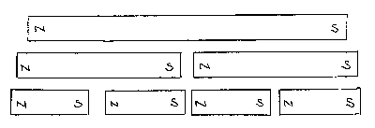

Magnetised Bar | Unmagnetised
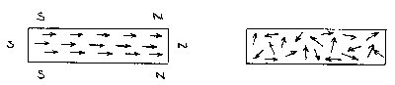

In an unmagnetised bar the "tiny" magnets point in all directions - the N pole of one neutralized by S pole of another. Their magnetic effects cancel out and there are no "free poles near the ends.

This theory explains:
- the breaking of a magnet
- limit to strength of magnet
- demagnetization
Destroying magnetism
This can be done by:
- hammering a magnet
- heating
- dropping a magnet
- demagnetizing by using reduced alternating current through a coil of wire wrapped round a magnet

Storing Magnets

Magnets become weaker with time (due to ‘free’ poles) near the ends repelling each other and upsetting alignment of tiny magnets).
To prevent this bar magnets are stored in pairs with unlike poles opposite and pieces of soft iron - keepers across the ends.
The keepers become induced magnets and their poles neutralise the poles of the bar magnets.
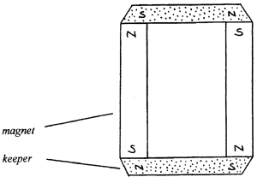

- Why should magnets be stored correctly?
____________________________________________________________________

- Can you do the balancing trick shown below? Explain how this works.
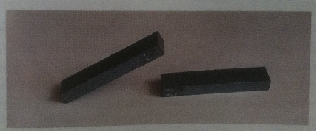
________________________________________________________________________________________________________________________________________________________________________________________________________________________________________________________________________

- List several uses of magnets.
________________________________________________________________________________________________________________________________________________________________________________________________________________________________________________________________________

Experiment: Poles Apart
Take two bar magnets and identify the north and south pole of each. Position the magnets near each other as shown. Take note of whether the magnets attract or repel each other in each case.

Why do magnets have ends called North and South?

Experiment: Testing A Variety of Objects for Magnetic Attraction

Magnets are made of alloys (mixtures of metals) that are mostly iron. Bar magnets used in schools are made of Alnico – iron mixed with aluminium, nickel, cobalt and copper.
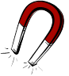
Aim: To determine which objects are magnetic.

Materials:

A variety of materials including nails, pens, coins, electrical wire, plastic, tin cans, aluminium cans, retort stand, gauze mat, wood, paper, glass.

Method:

Test a wide variety of materials or objects until you find 5 that are attracted to a magnet and five that are not. Fill in your results on the table.

Do not drop the magnets as this disrupts their ‘domains’ and causes them to lose magnetic force.

Results:

Magnetic vs Non-Magnetic Materials
Materials/Objects NOT Attracted to a Magnet | Materials/Objects Attracted to Magnets

Discussion:

What have all the material/objects that were attracted to magnets have in common?

Conclusion:
Materials or objects that are attracted to magnets all contain some …………..
Experiment: Magnetic Force – a Non-Contact Force
Some forces are contact forces – that is – surfaces must actually touch for the force to operate. Some forces are non-contact forces – the force can exert its effect at some distance from the object.
Aim: To demonstrate magnetism is a non-contact force.
Materials:

Cotton or light string (about 30 cm)
Magnet
Retort stand, boss head and clamp.
Paper clip
Plasticine

Method:
- Attach the paper clip to the cotton or string.
- Place the magnet in the clamp attached to the retort stand approximately 30 cm above the table.
- Stick the end of the cotton or string in the plasticine.
- Vary the distance between the cotton and string until the magnet is no longer able to attract the paper clip. Draw a labelled diagram of your experimental set-up in the box below.

Results:
The magnet was no longer able to attract the paper clip when it was moved ……………………cm away from the magnet.

Conclusion:
_______________________________________________________________________________________________________________________________________________________________________________________________________________________________________________________________________________________________________________________________________

Looking Inside Magnets page 164
Inside magnetic materials are _______ magnetic ________. These are called magnetic __________. When magnets are being __________, the magnetic domains are all ____________ to face the same _________. This creates a _________ magnet which lasts a _______ _______. It is a ____________ magnet.

Temporary magnets __________ their magnetism very __________. In temporary __________ only _______ of the ___________ __________ line up.

Pure iron (also called _______ iron) loses its ____________ easily. The iron-containing alloy in _________ magnets is called _______ iron. Hard iron ________ its ____________ for a long time.
Experiment – To magnetise a nail with electricity
Page 165: Follow the instructions.
The nail magnet can be tested using ____________________________-
The magnetic force can be increased by___________________________
Magnetise and demagnetise a large nail by stroking it with a permanent magnet. Test the magnetism using paper clips or pins. Then, drop it to destroy the magnetism. Record two observations from this experiment below.
____________________________________________________________________________________________________________________________________________________________________

Magnetic Fields
- What is a magnetic field?
____________________________________________________________________________________________________________________________________________________
- How could we see a magnetic field?
____________________________________________________________________________________________________________________________________________________
- Use a compass to trace the magnetic field around a bar magnet on a sheet of paper. How far does it extend?

- How can the N-pole seeking side of a compass point towards the North Pole?
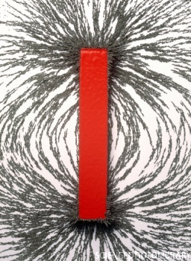
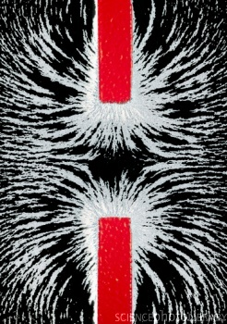
____________________________________________________________________________________________________________________________________________________
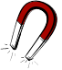
Types and uses of magnets
The permanent _________ you use at school are made of an ________ of iron. Another important group of magnetic _________ are called ___________.

The Earth is a _________. The Earth’s magnetism is sometimes called ____________. Accurate measurements of ____________ are made with a ____________.

