**Set Theory and Notation GREEN**

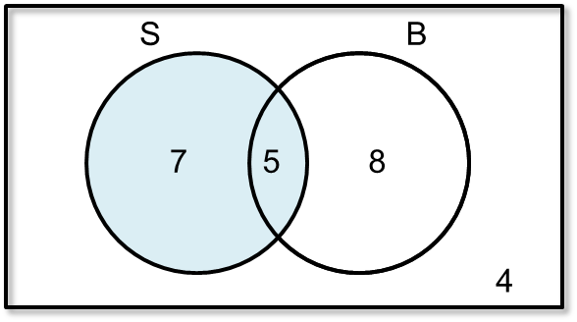**Question 1**

Mrs Smith asks 24 pupils in her class about their families. She sorts them into:

S - {has sisters}

B - {has brothers}

She showed her results on a Venn diagram.

a) Describe the shaded region in words.

_______________________________________________________

b) Describe the region S ’ ∪ B ’ in words.

_______________________________________________________

c) How many students are in S ’ ? _____

d) Work out P (S ∩ B). _____

e) Work out P (S ’ ∩ B). _____

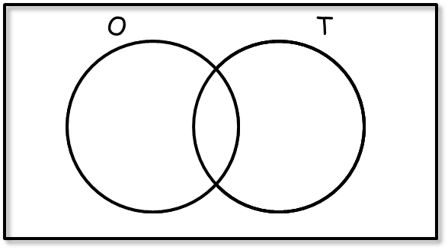**Question 2**

O – {odd numbers}

T – {Multiples of three}

a) Using numbers from 1 to 10, complete this Venn diagram.

b) Shade in the region showing a multiple of three but not an odd number.

c) Describe the region O ∪ T in words.

_______________________________________________________

d) How many numbers are in O ’ ? _____

e) Work out P (O ∩ T). _____

f) Work out P (O ∩ T ’). _____

**Question 3**

I = {the letters in the word India}

E = {the letters in the word Europe}

A= {the letters in the word America}

a) Complete the Venn diagram.

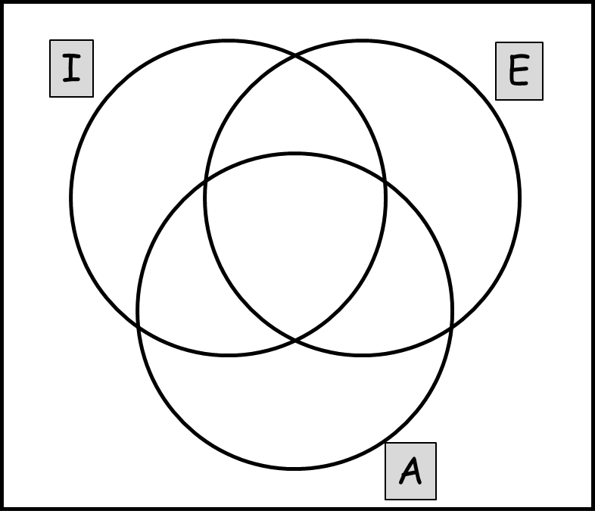

b) List the elements of I ∩ E: ______________________

c) List the elements of I ∩ A: ______________________

d) List the elements of A ∩ E: ______________________

e) How many elements are there in E ∪ I ? _____

f) How many elements are there in E ∪ A ? _____

g) How many elements are there in I ∪ A ? _____

h) How many elements are there in I ∩ A ‘ ? _____

i) How many elements are there in E ‘ ∩ A ‘ ? _____

**Set Theory and Notation AMBER**

**Question 1**

Mrs Smith asks 24 pupils in her class about their families. She sorts them into:

S - {has sisters}

B - {has brothers}

She showed her results on a Venn diagram.

a) Describe the shaded region in words.

_______________________________________________________

b) Describe the region S ’ ∪ B ’ in words.

_______________________________________________________

c) How many students are in S ’ ? _____

d) Work out P (S ∩ B). _____

Remember to express probability as a fraction, decimal or percentage.

e) Work out P (S ’ ∩ B). _____

**Question 2**

O – {odd numbers}

T – {Multiples of three}

a) Using numbers from 1 to 10, complete this Venn diagram.

b) Shade in the region showing a multiple of three but not an odd number.

c) Describe the region O ∪ T in words.

_______________________________________________________

d) How many numbers are in O ’ ? _____

e) Work out P (O ∩ T). _____

Remember to express probability as a fraction, decimal or percentage.

f) Work out P (O ∩ T ’). _____

**Question 3**

I = {the letters in the word India}

E = {the letters in the word Europe}

A= {the letters in the word America}

Make sure you include all 26 letters!

a) Complete the Venn diagram.



b) List the elements of I ∩ E: ______________________

c) List the elements of I ∩ A: ______________________

d) List the elements of A ∩ E: ______________________

e) How many elements are there in E ∪ I ? _____

f) How many elements are there in E ∪ A ? _____

g) How many elements are there in I ∪ A ? _____

h) How many elements are there in I ∩ A ‘ ? _____

i) How many elements are there in E ‘ ∩ A ‘ ? _____

**Set Theory and Notation RED**

**Question 1**

Mrs Smith asks 24 pupils in her class about their families. She sorts them into:

S - {has sisters}

B - {has brothers}

She showed her results on a Venn diagram.

a) Describe the shaded region in words.

_______________________________________________________

b) Describe the region S ’ ∪ B ’ in words.

Not S OR not B

_______________________________________________________

c) How many students are in S ’ ? _____

Not S

d) Work out P (S ∩ B). _____

Remember to express probability as a fraction, decimal or percentage.

e) Work out P (S ’ ∩ B). _____

**Question 2**

O – {odd numbers}

T – {Multiples of three}

a) Using numbers from 1 to 10, complete this Venn diagram.

b) Shade in the region showing a multiple of three but not an odd number.

c) Describe the region O ∪ T in words.

O OR T

_______________________________________________________

Not O

d) How many numbers are in O ’ ? _____

e) Work out P (O ∩ T). _____

Remember to express probability as a fraction, decimal or percentage.

f) Work out P (O ∩ T ’). _____

**Question 3**

I = {the letters in the word India}

E = {the letters in the word Europe}

A= {the letters in the word America}

Make sure you include all 26 letters!

a) Complete the Venn diagram.



I AND E

b) List the elements of I ∩ E: ______________

c) List the elements of I ∩ A: ______________

d) List the elements of A ∩ E: ______________

E OR I

e) How many elements are there in E ∪ I ? _____

f) How many elements are there in E ∪ A ? _____

g) How many elements are there in I ∪ A ? _____

I AND not A

h) How many elements are there in I ∩ A ‘ ? _____

i) How many elements are there in E ‘ ∩ A ‘ ? _____

Not E AND not A